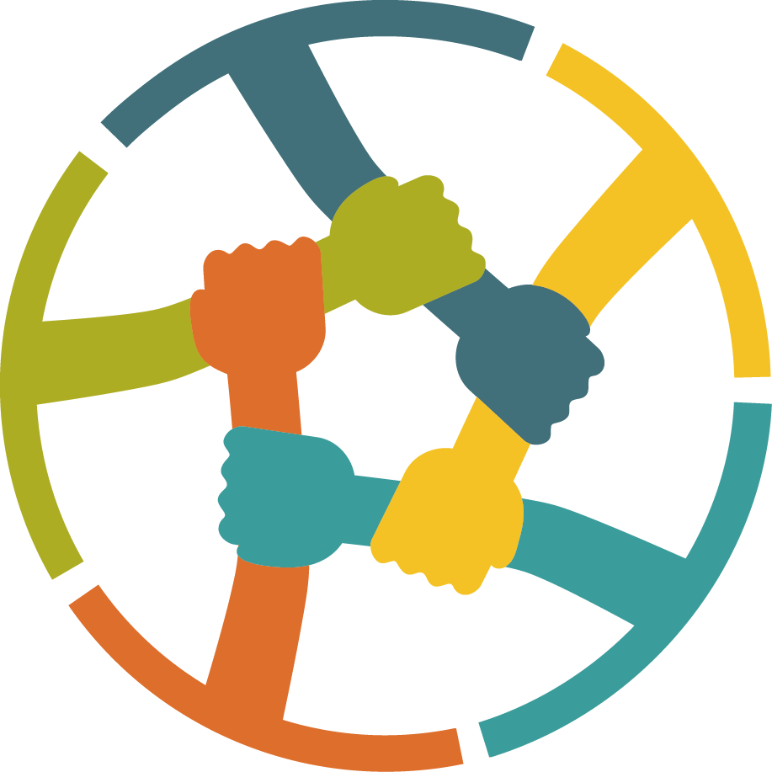
South West London Joint Child Neglect Strategy

Croydon, Kingston and Richmond, Merton and Wandsworth Safeguarding Children Partnerships

February 2025

Contents
1. Introduction 3
2. Vision and Principles 4
2.1 Our Vision 4
2.2 Our Principles 4
3. Definitions, Elements and Types of Child Neglect 6
3.1 Definitions 6
3.2 Types of Child Neglect 6
3.3 Key Elements of Child Neglect 7
3.4 The Conundrum of Neglect 7
3.5 Situational Contexts of Child Neglect 8
4. Key Issues and Challenges 8
4.1 The Impact of Child Neglect on Children 8
4.2 Understanding the Impact Across Different Age Groups 9
4.3 Voice of the Child 10
5. Roles and Responsibilities 11
5.1 Agency Roles and Responsibilities 11
5.2 Multi-Agency Collaboration 13
6. Identifying and Assessing Child Neglect 15
6.1 Assessment Tools and Frameworks 15
6.2 Early Identification Protocols 15
7. Monitoring and Evaluation 16
7.1 Measuring Improvement and Impact 16
7.2 Continuous Improvement 17
8. Resources and References 19

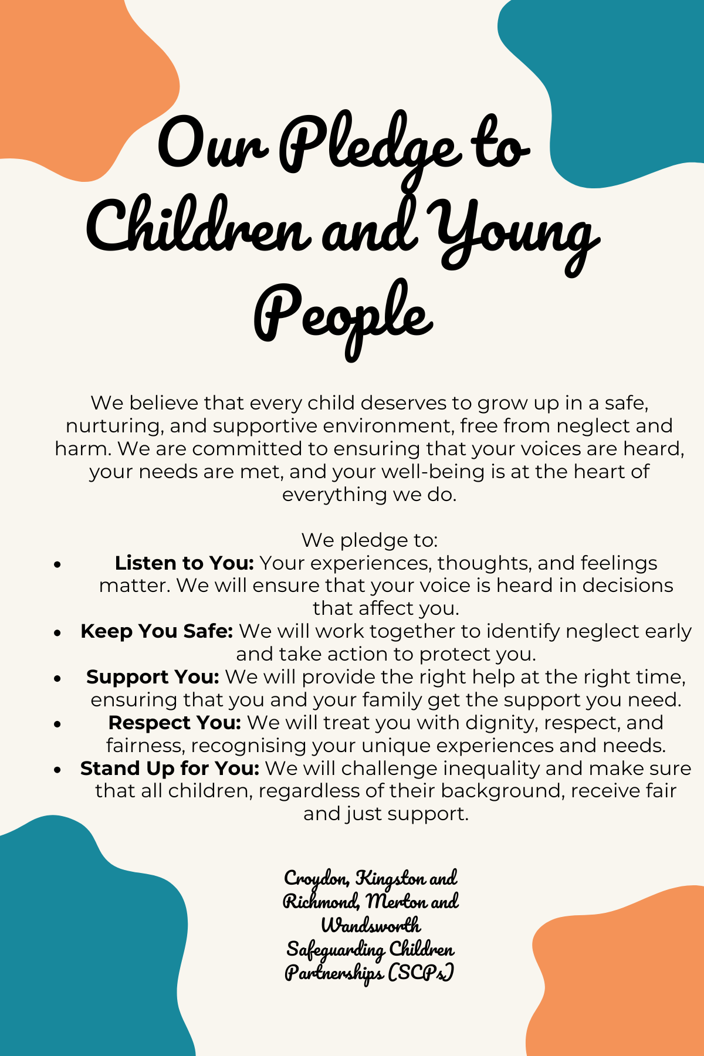

Introduction

This joint strategy represents a concerted effort by Croydon, Kingston and Richmond, Merton and Wandsworth Safeguarding Children Partnerships (SCPs), to address the critical issue of child neglect within our communities. The purpose of this strategy is to unify our approaches, resources, and expertise to ensure that all children receive the care and protection they need to thrive.

In this strategy, we intentionally use the term "child neglect" to ensure the focus remains on the child, their experiences, and the impact on their development. Referring to neglect in this way avoids abstracting the issue or describing it as an impersonal phenomenon e.g. "neglect is present in the home." Instead, it emphasises the responsibility of caregivers and the relational dynamics that contribute to the child's circumstances. This clarity helps ensure that conversations about neglect are centred on the child, highlighting the specific harm caused and the changes needed to improve their well-being.

Child neglect has become an increasing concern in the United Kingdom and it the most common form of abuse. An estimated 1 in 10 children in the UK experience some form of neglect. Concerns around child neglect are identified in about half of the children who are subject to a child protection plan or register. Additionally, police recorded nearly 37,000 child cruelty offences in 2023/24, a figure that has been increasing over recent years. Child neglect is frequently a factor in our Child Safeguarding Practice Reviews, which can be accessed via our Safeguarding Children Partnerships’ websites, highlighting its prevalence across South West London.

- Croydon SCP: Croydon SCP Website
- Kingston and Richmond LSCP: Kingston and Richmond SCP Website
- Merton SCP: Merton SCP Website
- Wandsworth LSCP: Wandsworth SCP Website

Child neglect is a pervasive issue that affects the health, well-being, and development of children across our boroughs. Recognising the shared challenges and the need for a cohesive response, our local authorities have come together to develop a strategy that aligns our efforts and establishes a comprehensive framework for action. By working collaboratively, we can enhance our effectiveness in preventing neglect, identifying at-risk children, and providing timely and appropriate interventions.

Our aims are to address child neglect proactively, minimising its long-term impact and enhancing the lives of children and young people who are at risk of or have already experienced neglect.

Vision and Principles

2.1 Our Vision
To create a safe, nurturing, and supportive environment for all children within our communities, where child neglect is swiftly identified, effectively addressed, and ultimately prevented through strong multi-agency partnerships. By working together, we aim to ensure that every child can grow up in a healthy and protective setting, free from the harm and adverse effects of child neglect, and where their well-being and potential are fully realised. This vision reflects our commitment to:
- Preventing Child Neglect: Through proactive and preventive measures, we aim to minimise the occurrence of neglect and its impact on children.
- Protecting Vulnerable Children: By ensuring early timely identification and intervention, we protect children at risk of or experiencing neglect.
- Promoting Well-being: We focus on enhancing the overall well-being of children and minimise long term impact by addressing the root causes of child neglect and supporting families in need.
- Working in Partnership: We are committed to fostering strong, collaborative partnerships between all agencies, professionals, and community organisations involved in safeguarding children. By working together, we ensure a coordinated, consistent, and effective response to child neglect across our communities.

2.2 Our Principles
Child-Centred Approach: Place the needs, rights, and voices of children at the forefront of all actions and decisions. This is to ensure children’s perspectives are considered in the development and implementation of policies and practices.
Early Intervention and Prevention: Prioritise early identification and support for families at risk to prevent child neglect before it occurs. We aim to utilise evidence-based tools and practices to detect early signs of child neglect and intervene promptly.
Multi-Agency Collaboration: We foster a collaborative approach among a broad range of services, including child services, healthcare, education, law enforcement, and community organisations. Additionally, we engage key internal council departments, such as Housing, Adult Social Care (ASC), Mental Health, and Substance Misuse Services, recognising their crucial role in identifying the early signs of child neglect. By establishing clear roles, responsibilities, and communication channels across these departments, we ensure a coordinated, comprehensive, and effective response to child neglect, leveraging the expertise of those most likely to encounter families at risk.
Consistency and Standardisation: Implement standardised assessment tools and frameworks to ensure uniformity in identifying and addressing child neglect, such as the Neglect Toolkit. This is to maintain consistent policies and procedures across all participating authorities to provide equitable support to children and families.
Professional Development and Learning: We commit to continuous learning and professional development for all practitioners involved in safeguarding children. Our aim is to provide regular training and resources to enhance the skills and knowledge required to tackle child neglect effectively.
Community Engagement: We encourage active participation from the community in identifying and preventing child neglect. This is to promote awareness and understanding of child neglect and its impact among community members, empowering them to contribute to safeguarding efforts.
Evidence-Based Practice: Utilise research and data to inform policy decisions and practices. In doing this we regularly review, and update strategies based on the latest evidence to ensure they remain effective and relevant.
Transparency and Accountability: Ensure transparency in processes and decision-making, allowing for accountability at all levels. This includes implementing robust monitoring and evaluation mechanisms to assess the effectiveness of the strategy and make necessary improvements.
Empowerment and Support: Focus on empowering families by providing them with the support and resources needed to overcome challenges. This is to promote resilience and self-sufficiency in families to help them provide better care for their children.
Respect for Diversity and Inclusion: We acknowledge and respect the diverse needs and backgrounds of children and families, including the disproportionate representation of Black, Asian and minoritised ethnic communities’ families in safeguarding processes. We are committed to ensuring that all actions and interventions are inclusive, culturally sensitive, and tailored to meet individual needs. We will actively challenge any biases and ensure that decision-making is fair, equitable, and just for families from all communities, addressing systemic inequalities and promoting equal outcomes for every child.

Definitions, Elements and Types of Child Neglect

3.1 Definitions

Working Together 2023 defines neglect as:
“Neglect - The persistent failure to meet a child’s basic physical and/or psychological needs, likely to result in the serious impairment of the child’s health or development. Neglect may occur during pregnancy as a result of maternal substance abuse. Once a child is born, neglect may involve a parent or carer failing to:
• provide adequate food, clothing, and shelter (including exclusion from home or abandonment)
• protect a child from physical and emotional harm or danger
• ensure adequate supervision (including the use of inadequate caregivers)
• ensure access to appropriate medical care or treatment
• provide suitable education It may also include neglect of, or unresponsiveness to, a child’s basic emotional needs”

A clear and comprehensive definition of child neglect is essential for ensuring a consistent and effective approach across all participating local authorities. Croydon, Kingston and Richmond, Merton and Wandsworth Safeguarding Children Partnerships recognise the definition of neglect as stated in the Working Together 2023 guidance.

3.2 Types of Child Neglect
Child neglect can occur at any stage in a child's life and may involve one or more of the following:
- Physical Neglect: The failure to provide adequate food, clothing, and shelter; failure to protect a child from physical harm or danger; failure to provide adequate supervision (including the use of inadequate caregivers); and failure to ensure access to appropriate medical care or treatment.
- Emotional Neglect: The failure to provide appropriate emotional support, love, and affection; failure to ensure a child’s emotional well-being and development; and failure to protect a child from emotional harm or danger.
- Educational Neglect: The failure to ensure a child receives an appropriate education, which includes failure to enrol a child in school, permitting chronic truancy, and failure to provide necessary special educational support.
- Medical Neglect: The failure to provide necessary medical care, which includes ignoring or delaying essential medical, dental, or mental health treatment. This includes instances where parents or caregivers do not accept a diagnosis or refuse treatment despite the child expressing a desire to engage with interventions. Failure to implement timely interventions may significantly impact the child’s long-term mental health outcomes.
- Nutritional Neglect: The failure to provide adequate nutrition, either by insufficient food or food lacking in nutritional value, impacting the child’s growth and development.
- Supervisory Neglect: The failure to provide adequate supervision, leading to the child being exposed to dangers or harmful situations, including inappropriate caregiving arrangements

3.3 Key Elements of Child Neglect

- Basic Needs: The term “basic needs” encompasses all fundamental aspects required for a child's healthy growth and development, including physical, emotional, educational, and medical needs.
- Persistent Failure: Child neglect involves ongoing, repeated failure to meet a child’s needs, rather than isolated incidents
- Serious Impairment: Child neglect must be of such severity that it is likely to cause significant harm to the child’s health or development.

3.4 The Conundrum of Neglect

Ray Jones outlines three distinct types of child neglect, which are critical for understanding and addressing child neglect effectively:

- Type 1: Passive Neglect
- Description: Neglect by omission, often due to parents being overwhelmed by circumstances such as chronic poverty, poor health, and lack of support.
- Characteristics: Parent/Carers are exhausted and lack the energy or resources to meet their children's needs. This results in a neglectful environment where children may lack boundaries, support, and supervision.
- Interventions: This could look like supporting parent/carers to help them regain the capacity to provide care effectively.
- Type 2: Chaotic Neglect
- Description: Child Neglect due to parent/carers lack of parenting skills and self-centred behaviours.
- Characteristics: Parent/Carers may be active but focus on their own needs rather than their children's. They might have had poor parenting themselves and lack understanding of their children's needs.
- Interventions: Parenting programs and family nurse partnerships to educate and support parents, confronting them about their behaviour's impact on their children.
- Type 3: Active Neglect
- Description: Deliberate and intentional neglect, often involving anger and control.
- Characteristics: Parent/carers intentionally neglect and scapegoat one or more children, which can quickly escalate into severe abuse.
- Interventions: Prompt and decisive action, including criminal investigation, prosecution, and removal of the abusive parent or child from the home.

3.5 Situational Contexts of Child Neglect
- Pre-natal Neglect: Child neglect can begin before birth, such as in instances where maternal substance abuse or lack of prenatal care leads to health issues for the newborn.
- Household Environment: Child neglect often occurs within the context of the home environment and can include situations where the home is unsafe, unsanitary, or where parents/caregivers are absent or unresponsive to a child's needs.
- Parental Mental Health and Parenting Capacities: Parental mental health issues, including depression, anxiety, or other untreated conditions, can significantly impair a parent's ability to provide consistent care. This can impact their parenting capacity, leading to child neglect of the child’s physical, emotional, and developmental needs. Recognising and addressing the mental health needs of parents is essential for safeguarding children.
- Impact on Development: Child neglect can affect various aspects of a child’s development, including physical health, cognitive abilities, emotional stability, and social skills.
- Affluence: Wealth and status of parents/carers can sometimes contribute to failing to meet their children's emotional and physical needs, e.g. isolating them in private fee-paying and boarding schools. These parents/carers can leverage their social and financial status to resist child protection interventions, frequently using legal means to challenge social workers and maintain control over their parenting choices. Additionally, wealthy parents can use private psychological support for their children's issues, which can be seen to slip under the radar of children services.
- Cultural or religious considerations: Cultural or religious beliefs and practices can sometimes lead to child neglect, particularly if they prioritise certain traditions or behaviours over the well-being of the child. This might include practices that limit a child's access to healthcare, education, or social integration, or that justify harsh disciplinary measures. It's essential for professionals to be culturally sensitive while also ensuring that children's rights and well-being are prioritised in all circumstances.
- Cost of Living Crisis: In the London context, the cost-of-living crisis has exacerbated financial strains on families, leading to housing instability, food insecurity, and increased parental stress. These economic pressures can diminish parents' capacity to provide adequate care, and in some cases, child neglect may stem from the overwhelming challenges of meeting basic needs. Ensuring support for families facing financial hardship is critical in preventing child neglect in this context.

Key Issues and Challenges

4.1 The Impact of Child Neglect on Children

In relation to child neglect, there are critical junctures where the risks are significantly heightened, and the impact on children can be severe and long-lasting. Addressing these junctures with appropriate and timely interventions is crucial for mitigating the adverse effects of child neglect.
Child neglect can have profound and lasting effects on various aspects of a child's development and well-being. The following are key areas impacted by child neglect:

- Physical Health:
  - Growth and Development: Neglect can result in malnutrition, stunted growth, and developmental delays. Chronic neglect may lead to long-term health problems and increased vulnerability to illnesses and injuries.
  - Poor Hygiene: Neglected children often suffer from poor personal hygiene, leading to skin conditions, dental problems, and other health issues.
- Emotional and Psychological Well-being:
  - Attachment Issues: Children who experience neglect may develop insecure attachments, leading to difficulties in forming healthy relationships and trust issues.
  - Mental Health Problems: Neglect is strongly associated with mental health issues such as anxiety, depression, low self-esteem, and post-traumatic stress disorder (PTSD).
- Cognitive and Educational Outcomes:
  - Learning Difficulties: Neglect can impair cognitive development, resulting in delayed educational development. Difficulties with concentration, memory, and problem-solving may affect a child's ability to engage in learning, leading to longer-term impacts on achieving their potential.
  - Educational Neglect: Lack of support for educational needs can limit a child's opportunities for future success and socio-economic mobility. This can include failure to provide adequate support for learning difficulties or additional educational needs.
  - School Attendance: Neglect can contribute to poor school attendance, which in turn affects academic performance, social integration, and access to pastoral support. Children experiencing neglect may struggle to attend school regularly due to lack of parental encouragement, unmet basic needs, or emotional distress.
- Social and Behavioural Development:
  - Social Skills: Neglected children may struggle with social interactions, leading to social isolation, difficulty making friends, and problems with peer relationships.
  - Behavioural Issues: Behavioural problems such as aggression, withdrawal, or antisocial behaviour are common among neglected children, often as coping mechanisms or responses to their environment.

4.2 Understanding the Impact Across Different Age Groups

- Babies in Utero: Child neglect can begin before birth when mothers are not accessing appropriate antenatal care, which can severely impact both the mother's mental and physical health as well as the safe and healthy development of the foetus. Lack of access to maternity services, including essential health checks, advice, and support during pregnancy, increases the risk of complications such as low birth weight and developmental issues in newborns. Substance misuse, including drug and alcohol use during pregnancy, can lead to significant harm, affecting the baby's development and increasing risks for both mother and child. Pre-birth assessments are crucial in identifying risks early on and planning necessary interventions to protect both the mother and the unborn child.
- Infants and Toddlers (0-3 years): Child Safeguarding Practice Reviews show that children under one year of age are particularly vulnerable to severe outcomes from child neglect, including fatal injuries. This is due to their physical fragility, invisibility within the broader community, and inability to articulate their needs. The physical and psychological strain on caregivers of newborns can contribute to child neglect. Comprehensive assessments of parental strengths and potential risks to unborn children are essential to identify those most at risk and manage their protection effectively.
- Preschool Children (3-5 years): Delays in language, social, and cognitive development. Neglected preschool children may exhibit a range of behavioural issues, from aggression and hyperactivity to withdrawal and anxiety, signalling underlying child neglect.
- School-Age Children (5-12 years): Poor academic performance, difficulties in social interactions, and increased risk of bullying. Transition periods, such as starting school, can be particularly challenging. Poor school attendance at this stage can significantly impact learning, peer relationships, and emotional well-being. Emotionally Based School Avoidance (EBSA), which may arise due to neglect, should be recognised as a key factor affecting engagement with education.
- Adolescents (12-18 years): Risky behaviours, mental health issues, and educational disengagement. Adolescents may suppress signs of child neglect or exhibit challenging behaviours that are misunderstood. This can lead to practitioners misinterpreting their behaviour as purely problematic rather than recognising it as a response to child neglect. At this stage, school attendance can also be severely impacted, further limiting educational opportunities and access to pastoral support. EBSA is particularly relevant for adolescents experiencing neglect, as feelings of anxiety, low self-worth, or lack of parental support can contribute to disengagement from education.
- Disabled Children and Young People: Disabled children are at an elevated risk of child neglect due to increased vulnerability, communication difficulties, and an inability to understand or seek help.
Children with behavioural or conduct disorders, speech and language difficulties, sensory impairments (deaf or blind), and complex health-related conditions are particularly vulnerable. These children often require specialised interventions tailored to their unique needs.
It is also important to consider that when children present with SEND (Special Educational Needs and Disabilities) it may be appropriate to consider if these children may also be experiencing severe and prolonged child neglect as the indicators may look the same or be interlinked. Therefore, there is a need to ensure professionals receive relevant training and supervision to support understanding of the impact of the child neglect on development and remain curious in their assessment.

4.3 Voice of the Child
Ensuring that the voice of the child is heard and considered in all decisions and actions related to child neglect is crucial. Children’s perspectives provide valuable insights into their experiences and needs. Key considerations for prioritising the voice of the child include:
- Active Participation:
  - Listening to Children: Professionals must actively listen to children and take their views and feelings into account. Creating an environment where children feel safe to express themselves is essential, especially if a child is pre or non-verbal or English is not their first language; being creative in ‘hearing’ the child’s voice
  - Encouraging Expression: Children should be encouraged and supported to share their thoughts and concerns without fear of judgement or repercussion.
- Child-Centred Approach:
  - Individualised Care: Tailored interventions and support to meet the unique needs and preferences of each child. Recognise that each child's experience of child neglect is different and requires a personalised approach.
  - Young Carers: Special attention must be given to children who act as young carers, as they may experience additional pressures and responsibilities. Recognising and addressing their dual roles as both children and carers is essential, ensuring that they receive appropriate support to manage their caregiving duties while still having their own needs met.
  - Empowerment: Empower children by involving them in decision-making processes about their care and support, ensuring they understand their rights and options.

- Feedback Mechanisms:
  - Regular Feedback: Establish regular feedback mechanisms to gather children’s views on the services and support they receive. This helps in understanding the effectiveness of interventions from the child's perspective.
  - Responsive Actions: Ensure that children’s feedback is used to inform and improve practices and interventions. Show children that their opinions matter and lead to real changes.
- Advocacy and Representation:
  - Advocated for children: Provide access to advocates who can represent the child’s interests and ensure their voice is heard in all relevant forums. Advocates can help articulate the child's needs and wishes, especially in legal or complex cases. Please note: Children on Child Protection Plans (CPP) and children with disabilities generally have access to advocates who can represent their interests and ensure their voice is heard in relevant forums. However, Children in Need (CiN) do not always have access to advocacy services unless spot-purchased or commissioned. We acknowledge the need to explore and potentially expand advocacy services to ensure all children receive appropriate representation when needed.
  - Legal Rights: Ensure children are aware of their rights and have access to legal representation if needed. Legal advocates can protect children's rights and help navigate the judicial system.

Roles and Responsibilities

5.1 Agency Roles and Responsibilities

Each agency involved in safeguarding children has specific roles and responsibilities to ensure a coordinated and effective response to child neglect. It is important to note that while the roles and responsibilities outlined in this section provide a general framework, the specific duties and processes may vary across different Safeguarding Children Partnerships. However, local and national learning highlights the importance of practitioners seeing children in their home environment to identify and evidence concerns around child neglect.
Each safeguarding partner might have unique protocols, resources, and operational structures that influence how these responsibilities are executed. Practitioners and agencies should refer to their respective SCP guidelines and frameworks to ensure that they are following the specific procedures and practices applicable to their region.

The following outlines the primary responsibilities of key agencies based on the existing strategies and procedures of Croydon, Kingston and Richmond, Merton, and Wandsworth Safeguarding Children Partnerships:

- Children Services:
Respond to referrals to children’s social care where child neglect is a factor of concern: When threshold is met, children services can be the lead agency responsible for coordinating the overall response to child neglect, such as co-ordinating interventions, regular reviews, and consistent support for children and their families. Please also review your local threshold documents via your SCP websites.
  - Child and Family Assessment: Conduct assessments of children and family’s needs, to provide help and support for families and identify the level of child neglect and necessary interventions to safeguard the child.
  - Escalation: If progress is not being made or if there are concerns about the effectiveness of interventions, practitioners should refer to their local escalation policy to ensure timely and appropriate actions are taken.
  - Training and Development: Provide continuous professional development and training to staff to ensure they are equipped with the necessary skills to address child neglect effectively.
  - Information Sharing: Share relevant concerns in a timely manner with other agencies to support a comprehensive understanding of the child's needs.
- Health (Includes for example: pharmacists, mental health, dentists, sexual health, allied head etc):
  - Health Assessments: Conduct regular health checks and assessments to identify signs of child neglect, such as malnutrition, poor hygiene, and untreated medical conditions.
  - Medical Support: Provide medical care and treatment for neglected children, including physical and mental health services.
  - Information Sharing: Share relevant health information in a timely manner with children services and other agencies to support a comprehensive understanding of the child's needs. Please refer to your local Was Not Brought (WNB) guidance for further information.
  - Specialist Services: Offer referrals to specialist health services when required to address complex health issues resulting from child neglect.
- Education and Early Years Practitioners:
  - Monitoring and Reporting: Teachers and early years practitioners should monitor children’s attendance, academic performance, and well-being. They work closely with designated safeguarding leads (DSL) in their school and consult with LA Safeguarding in Education officers to consider appropriate level of intervention.
  - Information Sharing: Share relevant concerns in a timely manner with children’s services and other agencies to support a comprehensive understanding of the child's needs.
  - Supportive Environment: Schools provide a safe and supportive environment for children, including counselling and additional educational support where needed.
  - Early Identification: Educators play a crucial role in the early identification of child neglect, recognising signs such as frequent absences, poor academic performance, and behavioural issues.
  - Parental Engagement: Work with parents to address any concerns and support the child's educational needs, providing resources and guidance where necessary.
- Police:
  - Investigation: Police investigate children experiencing severe child neglect that may involve criminal offences, such as child endangerment, exploitation or abuse.
  - Protection: Take immediate action to protect children in situations of severe child neglect or imminent danger.
  - Collaboration: Work closely with children’s services and other agencies to ensure the child’s safety and well-being, sharing information and participating in joint assessments.
  - Training: Provide specialised training for officers to recognise and respond to signs of child neglect effectively.
  - Information Sharing: Share relevant concerns in a timely manner with children’s services and other agencies to support a comprehensive understanding of the child's needs.
- Housing
  - Identification of Risk Factors: Housing officers and staff may be able to observe living conditions directly. They are responsible for identifying potential indicators of child neglect and should assess the level of risk when encountering substandard living conditions and engage in timely reporting to Children’s Services if there are safeguarding concerns. Recognising that poor housing conditions can be symptomatic of wider family issues; staff should refer to cases that meet safeguarding thresholds.
  - Intervention and Support: In collaboration with local authorities and social services, housing agencies support families by providing advice on tenancy, assisting with repairs, and facilitating relocations if unsafe living conditions are identified. They may also connect families to services that help with tenancy management, budgeting, or other relevant issues.
  - Information Sharing: Share relevant information with Children’s Services and other agencies in a timely manner to support the child’s overall welfare. Clear channels of communication with safeguarding partners ensure that housing issues are part of the broader assessment of the family’s situation.
  - Training and Awareness: Housing staff should receive regular training on safeguarding and be equipped to identify signs of child neglect. Awareness of the links between housing conditions and child welfare ensures that housing personnel can contribute effectively to safeguarding efforts.
- Community and Voluntary Organisations:
  - Support Services: Offer additional support services such as family counselling, parenting programmes, and emergency assistance to families in need.
  - Advocacy: Advocate for the needs and rights of neglected children and their families, ensuring their voices are heard in decision-making processes.
  - Community Engagement: Engage with the community to raise awareness about child neglect and encourage reporting and support for at-risk families.
  - Resource Provision: Provide resources and support to help families improve their parenting skills and create a safer environment for children.
  - Information Sharing: Organisations should be aware of their safeguarding responsibilities and to seek advice / make a referral when concerns are identified.
- Agencies Working with Adults:
  - Think Family Approach: Agencies that work primarily with adults, such as Housing, Safeguarding Adults Board, Mental Health, and Substance Misuse Services-must adopt a Think Family approach. This includes being vigilant to any concerns about children’s well-being and ensuring that these concerns are shared appropriately with Children’s Services. By considering the whole family context, these agencies play a critical role in safeguarding children.
  - Information Sharing: Share relevant concerns in a timely manner with children’s services and other agencies to support a comprehensive understanding of the child's needs.

5.2 Multi-Agency Collaboration
Effective multi-agency collaboration is essential to address the complex and multifaceted nature of child neglect. The following strategies enhance coordination and cooperation among different agencies:
- Joint Assessments:
  - Integrated Approach: Conduct joint assessments involving child services, healthcare, education, and police to develop a comprehensive understanding of the child's situation. This integrated approach ensures that all aspects of the child's well-being are considered.
  - Shared Tools: Use standardised approaches or tools and frameworks, across agencies to ensure consistency in assessments. This helps in providing a uniform approach to evaluating and responding to child neglect.
- Information Sharing:
  - Secure Systems: Implement secure information-sharing systems to facilitate timely and accurate exchange of information among agencies. Ensuring confidentiality and data protection is critical to maintaining trust and compliance with legal requirements.
  - Protocols: Establish clear protocols and guidelines for information sharing, ensuring that all agencies understand their responsibilities and the importance of sharing relevant information promptly.
- Regular Meetings and Child Protection Conferences:
  - Multi-Agency Meetings: Hold regular multi-agency meetings to discuss and review families, share insights, and coordinate interventions. These meetings help in aligning strategies and ensuring that all agencies are working towards common goals.
  - Child Protection Conferences: Organise child protection conferences where children are at risk of significant harm, bringing together all relevant agencies to develop and review action plans as part of a child protection plan.
- Training and Professional Development:
  - Joint Training Programmes: Develop and deliver joint training programmes to enhance understanding of child neglect, improve assessment skills, and foster collaboration. These programmes should be designed to address the specific needs of different agencies while promoting a unified approach.
  - Continuous Learning: Encourage continuous learning and professional development through workshops, seminars, and e-learning modules. Keeping up to date with the latest research and best practices is essential for all professionals involved in safeguarding children.
- Community Engagement and Awareness:
  - Awareness of Warning Signs: Safeguarding children is everyone’s business, and SCPs should aim to raise awareness of child neglect with utilities companies (e.g., water, gas, electric) and any others who visit family homes. Employees from companies such as British Gas, Royal Mail, and other service providers may notice warning signs during visits, including poor hygiene, unpleasant odours, an abundance of flies, or visibly unsafe living conditions. These observations can be critical for early intervention if reported appropriately.
  - Public Awareness Campaigns: Alongside targeted training for companies, community-wide public awareness campaigns should educate the general public about the signs of child neglect and how to report concerns. Engaging local organisations can help ensure that all members of the community are equipped to identify and report child neglect.
  - Reporting Concerns: Companies should have clear procedures for reporting concerns to Children’s Services or other safeguarding bodies. For example, if a postman observes severe child neglect signs, these situations should be reported following safeguarding protocols.
  - Safeguarding Training and Awareness: Companies with employees entering family homes should provide safeguarding training to help staff identify signs of child neglect and understand their reporting responsibilities. Training should include recognising both direct and subtle indicators of child neglect and understanding the appropriate referral pathways.
  - Engagement with Community Resources: SCPs should leverage local community resources and voluntary organisations to provide additional support and services to families in need. Where such organisations are known to be involved, ensure they are appropriately invited to multi-agency meetings to share insights and strengthen collaborative efforts.
- Clear Roles and Responsibilities:
  - Defined Roles: Name the lead agency and clearly define the roles and responsibilities of each agency involved in safeguarding children to avoid duplication of efforts and ensure accountability. Understanding each agency's role helps in creating a coordinated response.
  - Collaboration Agreements: Develop formal collaboration agreements or memoranda of understanding (MOUs) between agencies to outline commitments and expectations. These agreements provide a framework for effective collaboration and accountability.

Identifying and Assessing Child Neglect

6.1 Assessment Tools and Frameworks
Effective identification and assessment of child neglect require the use of standardised tools, approaches or practice frameworks. Each SCP employs specific tools to ensure a thorough and consistent evaluation of families where child neglect is a primary concern. Below are the assessment tools and frameworks that can be used by Croydon, Kingston and Richmond, Merton, and Wandsworth Safeguarding Children Partnerships:
- Graded Care Profile 2 (GCP2)
- Neglect Toolkit

Please explore your partnerships website to identify which one of these toolkits are used by your relevant partnerships:
- Croydon SCP: Croydon SCP Website
- Kingston and Richmond SCP: Kingston and Richmond SCP Website
- Merton SCP: Merton SCP Website
- Wandsworth SCP: Wandsworth SCP Website

6.2 Early Identification Protocols

For detailed information on early help and identification protocols, please refer to your respective LSCP. Each LSCP provides comprehensive guidelines and resources tailored to their local context. Practitioners should familiarise themselves with these resources to ensure they are following the most current and applicable procedures. Here are the links to the relevant LSCP Early Help guidance:

- Croydon SCP: Croydon SCP Website
- Kingston and Richmond LSCP: Kingston and Richmond SCP Website
- Merton SCP: Merton SCP Website
- Wandsworth LSCP: Wandsworth SCP Website

Monitoring and Evaluation

While the strategies for monitoring and evaluation described in this section aim to provide a unified approach, it is essential to acknowledge that each LSCP may have its own established methodologies and indicators for measuring improvement and impact. Local variations in data collection tools, review processes, and feedback mechanisms should be respected and integrated into the overall evaluation framework. Practitioners are encouraged to align these strategies with their SCP's specific monitoring and evaluation protocols to ensure consistency and relevance.

7.1 Measuring Improvement and Impact
The SCP’s use various approaches to measure improvement and impact in addressing child neglect. Here are some of the ways we can measure impact across all local authorities:
- Establishing Clear Objectives and Indicators:
  - Unified Key Performance Indicators (KPIs): Identify key performance indicators that all local authorities will track, such as:
    - The number and trend of child neglect concerns.
    - Child health, educational outcomes, and overall well-being.
    - Family engagement in support services.
    - Timeliness and effectiveness of interventions and case resolutions.
    - Rate and trends of re-referrals
    - Quality of anti-racist approach to decision- making
- Data Collection and Analysis:
  - Standardised Tools: Use standardised tools like the Graded Care Profile 2 (GCP2) and Neglect Toolkit across all SCPs to collect consistent data.
  - Quantitative Data: Collect quantitative data on various indicators, such as the number of reported children and families experiencing child neglect, the number of families receiving support and at what level, and intervention timelines.
  - Qualitative Data: Gather qualitative data through interviews, surveys, and case studies to capture the experiences and perspectives of children, families, and professionals involved in child neglect concerns.
- Regular Reviews and Reporting:
  - Periodic Reviews: Conduct quarterly and annual reviews to assess progress against objectives and KPIs.
  - Comprehensive Reports: Prepare detailed reports summarising the findings of reviews, highlighting successes, challenges, and areas for improvement. Share these reports with all stakeholders, including agency leaders, practitioners etc.
- Outcome Measurement:
  - Short-Term Outcomes: Measure immediate outcomes, such as the stabilisation of the child’s living conditions, access to necessary medical care, and improvements in school attendance and performance.
  - Long-Term Outcomes: Track long-term outcomes, including sustained improvements in child health, educational achievements, and overall family stability.

7.2 Continuous Improvement
To ensure continuous improvement, the following strategies will be implemented across all partner agencies across South West London
- Feedback Mechanisms:
  - Practitioner Feedback: Implement mechanisms for practitioners to provide feedback on the tools, processes, and outcomes of the child neglect strategy. This feedback is vital for identifying areas that need improvement and for understanding the practical challenges faced by professionals.
  - Family Feedback: Encourage families to share their experiences with the support services they receive. This feedback can help to identify gaps in service provision and areas where the approach can be more family centred.
  - Children and Young People’s Feedback: Actively seek the views and experiences of children and young people affected by child neglect. Their feedback is crucial to ensure that interventions are appropriate, and their voices are considered in shaping and improving services. Regular feedback opportunities should be provided in ways that are accessible, safe, and age appropriate. Young Scrutineers can also help with such feedback.
- Learning and Development:
  - Training Programmes: Regularly update and deliver training programs to ensure that all practitioners are equipped with the latest knowledge and skills to address child neglect. This includes training on new tools, best practices, and emerging trends in child protection.
  - Professional Development: Promote continuous professional development through workshops, seminars, and e-learning modules. Encourage practitioners to stay informed about new research and methodologies in the field of child protection.
- Audit and Quality Assurance:
  - Audits: Conduct regular Section 11 audits and audits of case files, intervention plans, and outcomes to ensure that the strategy is being implemented effectively and that standards are maintained.
  - Quality Assurance Processes: Establish quality assurance processes to review the consistency and quality of assessments, interventions, and follow-ups. Use the findings from these processes improve day-to-day practice.
- Adapting to Change:
  - Policy and Procedure Updates: Continuously review and update policies and procedures to reflect changes in legislation, emerging research, and best practices. Ensure that all stakeholders are aware of and adhere to the updated guidelines.
  - Innovation and Adaptation: Encourage innovation in practices and be open to adopting new approaches that may improve outcomes for children and families. Pilot new initiatives and evaluate their effectiveness before wider implementation.
- Collaborative Improvement:
  - Multi-Agency Collaboration: Foster a culture of collaboration among all agencies involved in the child neglect strategy. Share insights, successes, and challenges, and work together to develop solutions.
  - Community Engagement: Engage with the community to gather input and feedback on the child neglect strategy. This can help to ensure that the strategy remains relevant and effective in meeting the needs of children and families.

Resources and References

- Bruising and Non Accidental Injuries (NAI) in Pre-Mobile Infants and Children Protocol – WSCP
Available at: https://www.wscp.org.uk/media/mdkfevyy/bruising_in_non_mobile_babies_and_children_protocol_october_2023.pdf
- Brusing in non-mobile babies: A protocol for assessment, management, and referral by professionals- KRSCP
Available at:
https://kingstonandrichmondsafeguardingchildrenpartnership.org.uk/media/pnwehfur/krscp_bruising_in_non_mobile_babies_protocol.pdf
- Cathleen Halligan & Sarah Cryer, Emotionally Based School Avoidance (EBSA): Students’ Views of What Works in a Specialist Setting - Children & Young People’s Experiences, Volume 3, Issue 1, 2022.
Available at: https://continuityineducation.org/articles/10.5334/cie.38
- Child Safeguarding Practice Review Panel Annual Report 2022 to 2023
Available at: https://assets.publishing.service.gov.uk/media/65bce1df7042820013752116/Child_Safeguarding_Review_Panel_annual_report_2022_to_2023.pdf
- Croydon Child Wellbeing Tool
Available at: https://www.croydonlcsb.org.uk/croydon-neglect-strategy
- Croydon Local Child Safeguarding Practice Review ‘Ben’
Available at: https://www.croydonlcsb.org.uk/sites/default/files/10261667/2023-07/ben-7-learning-briefing_0.pdf
- Croydon Local Child Safeguarding Review ‘Carl & Max’
Available at: https://www.croydonlcsb.org.uk/sites/default/files/10261667/2023-07/carl-max-7-minute-briefing_0.pdf
- Kingston and Richmond Safeguarding Children Partnership - Neglect Toolkit
Available at: https://kingstonandrichmondsafeguardingchildrenpartnership.org.uk/media/y3ujnjb3/kingston_richmond_lscb_child_neglect_toolkit_in_depth.pdf
- Kingston and Richmond Safeguarding Children Partnership - Signs of Safety
Available at: https://kingstonandrichmondsafeguardingchildrenpartnership.org.uk/guidance-policies-and-procedures/signs-of-safety/
- Learning for the Future: Final Analysis of Serious Case Reviews, 2017 to 2019
Available at: https://assets.publishing.service.gov.uk/media/6396fdf8e90e077c33497013/Learning_for_the_future_-_final_analysis_of_serious_case_reviews__2017_to_2019.pdf
- London Safeguarding Children Procedures and Practice Guidance
Available at: https://www.londonsafeguardingchildrenprocedures.co.uk/
- London Safeguarding Children Procedures - Neglect
Available at: https://www.londonsafeguardingchildrenprocedures.co.uk/neglect.html
- Merton Safeguarding Children Partnership - Neglect Toolkit
Available at: https://www.mertonscp.org.uk/documents/neglect-toolkit/
- NSPCC Learning - Graded Care Profile 2 (GCP2)
“A strengths and evidence-based assessment tool to measure the care quality parents or carers give a child”
Available at: https://learning.nspcc.org.uk/services-children-families/implementation-support-for-nspcc-services/graded-care-profile-2-gcp2
- NSPCC Learning - Learning from Case Reviews: Neglect
Available at: https://learning.nspcc.org.uk/research-resources/learning-from-case-reviews/neglect
- NSPCC Learning Podcast: Child Neglect - Why Neglect Can Happen and How to Support Families
Available at: https://youtu.be/QMbHgHtje-w
- NSPCC Learning: Statistics briefing: Neglect
Available at: https://learning.nspcc.org.uk/research-resources/statistics-briefings/child-neglect
- Professor Claudia Bernard, An Exploration of How Social Workers Engage Neglectful Parents from Affluent Backgrounds in the Child Protection System
Available at: https://www.gold.ac.uk/research/case-studies/social-work-with-affluent-families/
- Ray Jones, The Conundrum of Neglect - Professional Social Work April 2016
Available at: https://southamptonscp.org.uk/wp-content/uploads/2020/06/Ray-Jones-3-types-of-neglect.pdf
- Research in Practice - Triennial Analysis of Serious Case Reviews 2017-2019
Available at: https://scr.researchinpractice.org.uk/media/zomdjieq/triennial-analysis-of-serious-case-reviews-2017-19-social-care-2022.pdf
- Rethinking ‘Did Not Attend’ Animation
Available at: https://www.youtube.com/watch?v=dAdNL6d4lpk
- Safeguarding Children from Black, Asian and Minoritised Ethnic Communities | NSPCC Learning
Available at: https://learning.nspcc.org.uk/safeguarding-child-protection/children-from-black-asian-minoritised-ethnic-communities
- Wandsworth School Attendance Advice
Available at: https://www.wandsworth.gov.uk/media/4161/school_attendance_advice.pdf
- Wandsworth- Outstanding Practice Framework
Available at: https://www.wandsworth.gov.uk/media/12587/outstanding-practice-_quality-assurance-framework.pdf
- Working Together to Improve School Attendance - GOV.UK
Available at: https://www.gov.uk/government/publications/working-together-to-improve-school-attendance
- Working Together to Safeguard Children 2023 - GOV.UK
Available at: https://assets.publishing.service.gov.uk/media/669e7501ab418ab055592a7b/Working_together_to_safeguard_children_2023.pdf

National Society for the Prevention of Cruelty to Children (NSPCC), (2024), Statistics briefing: Neglect. London: NSPCC Learning. Page 1 https://learning.nspcc.org.uk/research-resources/statistics-briefings/child-neglect
Ibid.
Ibid.
Ibid., p. 8.
Halligan, C. & Cryer, S. (2022). Emotionally Based School Avoidance (EBSA): Students’ Views of What Works in a Specialist Setting. Children & Young People’s Experiences (CIE)

