Croydon Safeguarding Children Partnership
Rapid Review & LCSPR Briefing



April 2026

Purpose of this Briefing
This briefing provides the CSCP Review Group members with a clear and consistent framework for understanding:
- When a SIN is required
- When a Rapid Review must take place
- The statutory criteria for a Local Child Safeguarding Practice Review (LCSPR)
- How to distinguish cases that require an LCSPR from those that do not
Its aim is to support confident, evidence-led decision-making.

Statutory Foundations
Working Together to Safeguard Children 2026 (WT2026)
WT2026 strengthens expectations on safeguarding partners to make timely, well-evidenced decisions about serious incidents. It clarifies when incidents must be notified, when Rapid Reviews must be conducted, and how learning should be captured and acted upon.
Child Safeguarding Practice Review Panel (CSPRP) Guidance for Safeguarding Partners (June 2025)
The CSPRP guidance provides non-statutory but nationally authoritative guidance outlining:
- what constitutes a serious incident
- when notifications and Rapid Reviews are required
- what factors Rapid Reviews must consider
- when a case meets LCSPRs criteria

SIN Notifications
A Serious Incident Notification (SIN) will be submitted by the local authority because a child:
- Has died or
- Has been seriously harmed, and
- Abuse or neglect is known or suspected
A SIN is also submitted by the LA when a care experienced person under the age of 25 dies from any cause. This does not trigger a Rapid Review unless the child is also under 18 and neglect or abuse is known/suspected.

Definitions – Seriously Harmed, Abuse and Neglect
Seriously Harmed:
A child is considered seriously harmed if they have suffered life-changing physical or psychological harm—a level of impact well beyond routine child protection thresholds
It also includes serious and/or long-term impairment of a child’s mental health, intellectual, emotional, social, behavioural, or physical development—even if recovery later occurs.
Abuse includes:
- Any physical, emotional, sexual abuse or exploitation, including online harms, when there is known or suspected evidence that it has caused or contributed to serious harm.
- Domestic abuse exposure, coercive control, teen relationship abuse, honour-/faith-based abuse, and child sexual exploitation (CSE) are explicitly called out in Working Together 2026 as types of abuse that must be considered.
Neglect
The persistent failure to meet a child's basic needs—physical and/or psychological—which is likely to result in serious impairment to health or development.
The CSPRP guidance states:
- SIN notifications must take place within 5 working days of the safeguarding partner becoming aware that the incident has occurred.
- Rapid Reviews must take place within 15 working days from the date the SIN is submitted
- The DSPs must sign off the rationale and LCSPR decision within the same 15-day window.
- If an LCSPR is commissioned, it should be completed within six months.
All three safeguarding partners have equal responsibility in determining whether an incident meets the criteria for notification and for contributing relevant information. As a minimum, the DCS should have final oversight of the quality and accuracy of the SIN that is submitted.
Where safeguarding partners have determined the criteria for serious incident notification has not been met, they may choose to undertake their own local learning reviews outside of the formal review process. For example, where there is an opportunity to learn from good or poor practice, or from a near-miss incident. The Case of Concern Process would be followed instead.

Key Principles for Rapid Reviews
- Submitting a SIN triggers a Rapid Review (except for in the case of an 18-25 year old care experienced). The CSCP Business Team will co-ordinate the Rapid Review (this includes liaison with CSAB/PH/CSP to determine the most appropriate vehicle for a review/joint review)
- Any professional asked to contribute to a Rapid Review must give it priority
- A DSP will ideally chair the Rapid Review – this may be delegated
- The DSPs must sign off the rationale and LCSPR decision within the same 15-day window.
- If an LCSPR is commissioned, it should be completed within six months.
The purpose of the Rapid Review is to:
  - gather the facts about the case, as far as they can be readily established, including details of agency involvement and an analysis of key practice episodes
  - discuss whether any immediate action is needed to ensure children’s safety and share any learning appropriately
  - consider the potential for identifying improvements to safeguard and promote the welfare of children
  - to understand the context of children’s and families’ lives including how racism and other inequalities related to other protected characteristics including disability may have influenced children’s and families’ experiences and the quality of practice.
  - establish whether the criteria for an LCSPR are met (determined by Review Group Members only)
  - decide what steps they should take next, including whether to undertake a local child safeguarding practice review or recommend a national review (complex or of national importance)
- Decisions must be based on evidence, not personal interpretation.
- The DSPs make the final decision on whether the criteria is met and whether to commission a LCSPR.

Criteria for a Local Child Safeguarding Practice Review (LCSPR)
While a Rapid Review is the usual route for determining whether a LCSPR should be commissioned, Working Together 2026 and CSPRP guidance allow an LCSPR to be commissioned where the partnership judges that local multi-agency learning is required and that an LCSPR is the most appropriate vehicle. In this case, the referring agency should submit a Case of Concern and the decision whether to commission a LSCPR will be made by the CSCP Review Group.
Reviews should seek to prevent or reduce the risk of recurrence of similar incidents. They are not conducted to hold individuals, organisations, or agencies to account as there are other processes for that purpose, including employment law and disciplinary procedures, professional regulation and, in exceptional cases, criminal proceedings. These processes may be carried out alongside a review or at a later stage.
Employers should consider whether any disciplinary action should be taken against practitioners whose conduct and/or practice falls below acceptable standards and should refer to their regulatory body as appropriate.
CSPRP guidance states that LCSPRs are required where:
- A child has died or been seriously harmed, and
- Abuse or neglect is known or suspected, and
- The case highlights or may highlight important lessons for multi-agency safeguarding practice.
Indicators of ‘important lessons for multi-agency safeguarding practice’ include:
- there is cause for concern about the actions of a single agency
- the case highlights or may highlight improvements needed to safeguard and promote the welfare of children, including where those improvements have been previously identified
- there has been no agency involvement, and this gives cause for concern
- the case highlights or may highlight recurrent themes in the safeguarding and promotion of the welfare of children
- more than one local authority, police area or ICB is involved, including in cases where a family has moved around
- the case may raise issues related to safeguarding or promoting the welfare of children in institutional settings
- the case highlights or may highlight concerns regarding two or more organisations or agencies working together effectively to safeguard and promote the welfare of children
- the case is one the National Panel has considered and has concluded a local review may be more appropriate
WT2026 emphasises that systemic learning must be prioritised, particularly in:
- Incidents That Suggest Systemic Weaknesses in Safeguarding Arrangements
- Multi-agency decision-making may have broken down
- Risk was not adequately assessed or responded to
- Children’s voices and lived experiences were not understood
- Inequalities, discrimination, or disproportionality may have influenced decisions or outcomes
These incidents must be reviewed because they reveal systemic fail points — a priority under the WT2026 emphasis on analysing disproportionality, strengthening practice standards, and improving data-driven governance.
- 3. Incidents That Involve “Hidden Harms” or Complex Forms of Abuse
- Child sexual abuse, including familial CSA
- Domestic abuse
- Coercive control
- Abusive behaviours in intimate teenage relationships
- Group-based exploitation and online harms
- Harms outside the home (extrafamilial harm)
WT2026 emphasises learning from these categories because evidence shows they are often under-identified and require multi-agency coordination improvements.
- Cases Involving Children Facing Multiple or Intersectional Harms
WT2026 acknowledges that children often face multiple forms of harm simultaneously (e.g., domestic abuse, CSA, neglect, exploitation). It places explicit emphasis on:
- Intersectionality
- Racism and discrimination
- Cumulative harm
- Hidden or less visible vulnerabilities
When a serious incident occurs in which these intersecting factors played a role, partners are expected to review it because such cases frequently expose system-level blind spots.

- Incidents Suggesting Failure of Multi-Agency Child Protection Standards
WT2026 introduces new national multi-agency child protection standards. Incidents that demonstrate:
- Failure to follow standards
- Drift or delay in protection
- Poor assessment quality
- Weak safety planning
- Lack of professional challenge
are considered important triggers for review because they expose where the system is not functioning as required.
In summary, WT2026 explicitly requires that partners follow the CSPRP framework for notifications and reviews. That framework identifies serious incident categories that must be reviewed for systemic learning, including:
- Cases indicating failures in multi-agency working
- Cases involving organisational abuse, e.g., harm in schools, care homes, hospitals
- Cases involving risk from people outside the home, including criminal or sexual exploitation
- Cases where professional practice concerns may have contributed to harm

When a Case Meets LCSPR Criteria BUT Commissioning a Review Is Not Appropriate

CSPRP guidance states:

Many serious incidents will capture learning that is already known in the system through other local or national published reviews. We encourage safeguarding partnerships to reflect on the learning from national reviews and consider how this is being acted on locally. Where an incident reflects issues already explored, safeguarding partners should carefully consider what additional local learning is likely to be achieved through an LCSPR. Well-constructed rapid reviews can draw out significant learning that negates the need to proceed to an LCSPR.

Appropriate reasons not to commission an LCSPR
A review may meet the criteria but not be appropriate when:

1. No potential for multi-agency learning exists
For example:
- All agencies responded appropriately.
- The circumstances were unforeseeable.
- The incident offers no additional insight beyond established national and local learning
- The key learning themes are well evidenced and clearly articulated (with relevant actions where appropriate)

2. Critical information is subject to legal constraints
For example:
- Active criminal proceedings where disclosure risks prejudicing a trial.
- Family courts restricting information sharing.

3. Another statutory review is a better vehicle for learning and duplication would delay learning
For example:
- Domestic Abuse Related Death Reviews (DARDs)
- Safeguarding Adults Review (SAR)
- MAPPA reviews
- Single agency Serious Incident Review (eg NHS, CAMHS)

4. A thematic route offers better impact
WT2026 and CSPRP both endorse using thematic learning where it will produce more systemic insights.

5. Family circumstances or trauma make a full LCSPR disproportionate
CSPRP guidance emphasises the need to consider family impact.
For example:
- Severe parental trauma
- Parallel bereavement processes

See flow chart below
See The Safeguarding Practice Review Process | Croydon Safeguarding

Flow Chart – to aid decision making:
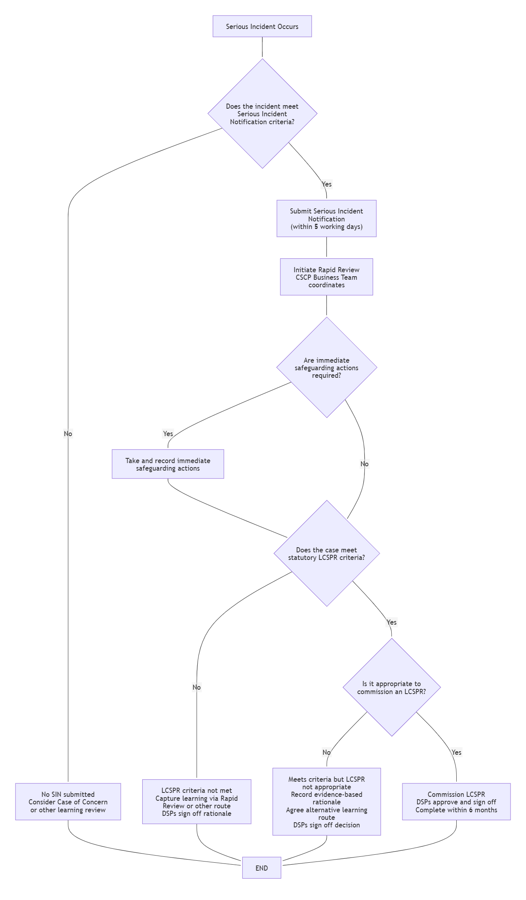

Glossary of Terms
CSP – Community Safety Partnership
CSPRP – Child Safeguarding Practice Review Panel
CSAB – Croydon Safeguarding Adults Board
CSCP – Croydon Safeguarding Children Partnership
DARD – Domestic Abuse Related Death Review
DCS – Director of Children’s Services
DSP – Designated Safeguarding Partner
ICB – Integrated Care Board
LCSPR – Local Child Safeguarding Practice Review
MAPPA – Multi-Agency Public Protection Arrangements
MARAC – Multi-Agency Risk Assessment Conference
MASH – Multi-Agency Safeguarding Hub
NHS – National Health Service
PH – Public Health
SAR – Safeguarding Adults Review
SIN – Serious Incident Notification
WT2026 – Working Together to Safeguard Children 2026

