Case of Concern Policy (COC)

The CSCP has a statutory responsibility to:
- identify and review serious child safeguarding cases which, in their opinion, raise issues of importance in relation to their area
- commission and oversee the review of those cases if they consider it

Serious child safeguarding cases are those in which:
- abuse or neglect of a child is known or suspected
- the child has died or been seriously harmed

In such cases a Serious Incident Notification will be submitted to the National Panel and it will trigger the Rapid Review Process (see CSCP Review Process)

A CoC is a case (or series of cases) where a child or unborn has experienced a near miss safeguarding event AND there is multi-agency learning which if applied, would reduce the likelihood of future events.

A near miss safeguarding event is defined as:
- Incidents where a child (under 18) or unborn, has been at risk of significant harm or death AND if it was not for an unintended consequence, the risk was very likely to occur.
- Early warning signs that something in a safeguarding system isn’t working and if left unchecked is likely to result in significant harm or death of a child or unborn.

A CoC is NOT a Statutory process. The CSCP recognise there is value in learning from near miss events and believe offering this process, will influence safeguarding systems and future practice. Any professional can raise a CoC. This form is designed to support the professional to work through a potential CoC incident and either share the learning or raise the matter to the CSCP Review Group for a decision on:
- whether it meets the definition of a Case of Concern
- what action should occur to capture the learning, influence safeguarding systems or future practice.

The professional referring the case should complete sections 1-6 below.
- If you are a professional receiving this form, please research your own agency information to bring to any meetings which have been convened.

This form should NOT be used to escalate a case as this is not a time critical process. To escalate a case (where agencies or professionals have differing opinions on safeguarding decisions or actions) follow The Escalation and Resolution Policy which provides a structured process to follow, ensuring that any conflicts are addressed effectively and in the best interest of the child.

You can contact cscp@croydon.gov.uk if you require any advice completing this form, or contacting relevant professionals

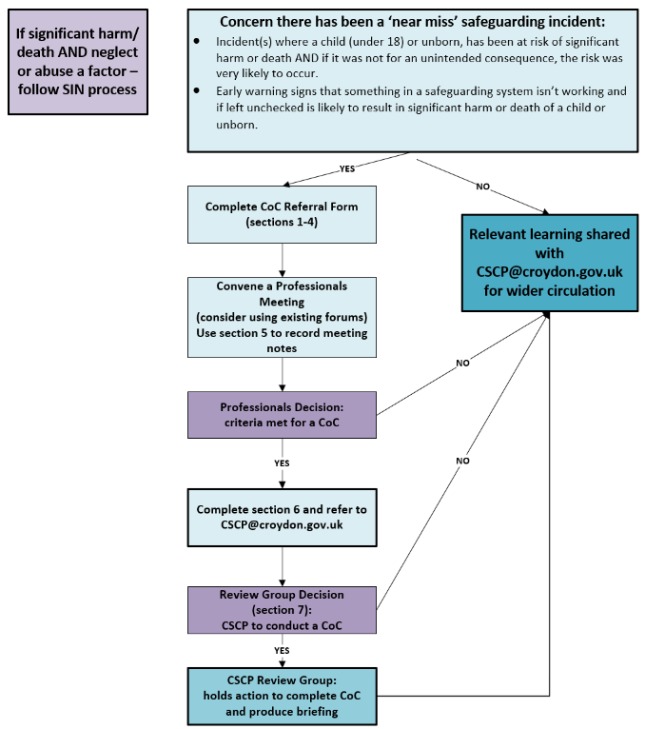
Flowchart to aid decision making:

- Referrer Details:
Your Name | Your Role
Your Agency | Email
Date of referral | Click or tap to enter a date.
- Details Of Child/ Young Person
Full Name
Date of Birth | Click or tap to enter a date. |  | Date of Death (if applicable) |  | Click or tap to enter a date.
Home address
Ethnicity | Choose an item. |  | Gender at birth |  |  | Choose an item.
SEND | Choose an item. |  | Is the gender they identify with the same sex registered at birth? |  |  | Choose an item.
NHS Number (Health only) |  | CRS Number (Social Care only) |  | PNC Number (Police only)
- Family/Significant Others and Household Details
Name | Relationship to child | Gender | Date of Birth
Add lines as required
Address:
- Describe how this case meets the definition of a near miss safeguarding event:
Briefly describe the event:

What learning/improvement do you hope to elicit:

How should this learning be shared to reduce the likelihood of a future incident (for this or another child/unborn):

- Convene a professionals meeting:
There are a number of suitable forums to review incidents. Any agency can arrange a professional’s discussion to review a case they are concerned about and share relevant learning or systems/practice improvements. The meeting can be arranged by the professional concerned inviting relevant people, or by utilising a suitable forum:

Examples of existing relevant forums include:
Forum | Contact
The Health/Children Social Care Liaison | Dawn.West@croydon.co.uk
Thinking Spaces: | Jo.George@croydon.gov.uk
MASH Operational Group (MASH Related) | MASH@croydon.gov.uk
Croydon University Hospital Safeguarding | SusanHemming-Clark@nhs.net
GP | Sharon.Raymond@swlondon.nhs.uk
SLaM/CAMHS Quality Huddle | Alison.Eley@slam.nhs.uk

The professionals meeting should include the relevant agencies specific to this case to gather the facts/clarify any ambiguities and secure the information below: You can share this form as your paper for the meeting:

Date of meeting:

Which agencies were present:

Key learning themes: (also complete section 6 below)

Actions:

Decision:
- The criteria for a near miss safeguarding event is NOT MET because:

now send this form to CSCP@croydon.gov.uk who will determine how best to share the relevant learning (please also ask your agency CSCP representative to include a brief summary on their next Partner Update Form)
OR

- The criteria for a near miss safeguarding event IS MET because:

now complete section 6 below

- What are you expecting from a CSCP Review of this case? i.e. what do you think they can do differently to your professionals meeting? Suggest questions that could be asked to elicit the learning?

- For CSCP Business Team only
Date received: Date discussed with Review Group Chair:
Decision: Proceed to Review Group Y/N:
Rationale:
Outcome of Review Group | Y/N | Which Agency(s) Involved | Grounds for decision:
Decision made to conduct a Case of Concern led by the CSCP. | Choose an item.
Suggested Methodology
Date proposed for final report at Review Group
Any other actions (with name/date)
Date of Review Group Meeting:
Chair of Review Group Meeting:

