Case of Concern (COC) Referral Process

The CSCP has a statutory responsibility to:
- identify and review serious child safeguarding cases which, in their opinion, raise issues of importance in relation to their area
- commission and oversee the review of those cases if they consider it
Serious child safeguarding cases are those in which:
- abuse or neglect of a child is known or suspected
- the child has died or been seriously harmed
In such cases a Serious Incident Notification will be submitted to the National Panel, and it will trigger the Rapid Review Process (see CSCP Review Process)
A COC is a case (or series of cases) where a child or unborn has experienced a near miss safeguarding event and there is multi-agency learning which if applied, would reduce the likelihood of future events.
A near miss safeguarding event is defined as:
- Incidents where a child (under 18) or unborn, has been at risk of significant harm or death AND if it was not for an unintended consequence, the risk was very likely to occur.
- Early warning signs that something in a safeguarding system isn’t working and if left unchecked is likely to result in significant harm or death of a child or unborn.
A COC is not a Statutory process. The CSCP recognise there is value in learning from near miss events and believe offering this process, will influence safeguarding systems and future practice. Any professional can raise a COC. This form (see appendix) is designed to support the professional to work through a potential COC incident and either share the learning or raise the matter to the CSCP Review Group for a decision on:
- whether it meets the definition of a Case of Concern
- what action should occur to capture the learning, influence safeguarding systems or future practice.
The professional referring the case should complete sections 1-6 below.
- If you are a professional receiving this form, please research your own agency information to bring to any meetings which have been convened.
This form should NOT be used to escalate a case as this is not a time critical process. To escalate a case (where agencies or professionals have differing opinions on safeguarding decisions or actions) follow The Escalation and Resolution Policy which provides a structured process to follow, ensuring that any conflicts are addressed effectively and in the best interest of the child.
You can contact cscp@croydon.gov.uk if you require any advice completing this form, or contacting relevant professionals

Flowchart to aid decision making
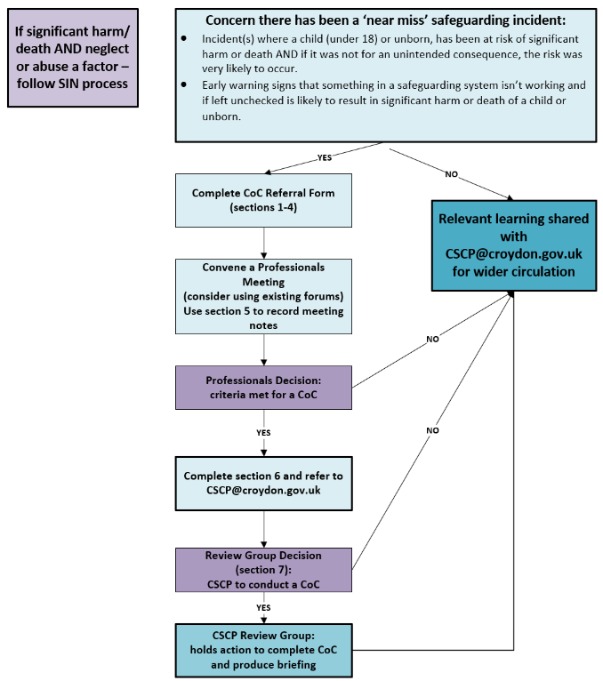

Appendix:

Case of Concern Referral Form

1. Referrer Details
Your Name | Your Role
Your Agency | Email
Date of referral | Click or tap to enter a date.

2. Details Of Child/ Young Person
Full Name
Date of Birth | Click or tap to enter a date. |  | Date of Death (if applicable) |  | Click or tap to enter a date.
Home address
Ethnicity | Choose an item. |  | Gender at birth |  |  | Choose an item.
SEND | Choose an item. |  | Is the gender they identify with the same sex registered at birth? |  |  | Choose an item.
NHS Number (Health only) |  | CRS Number (Social Care only) |  | PNC Number (Police only)

3. Family/Significant Others and Household Details
Name | Relationship to child | Gender | Date of Birth
Add lines as required
Address:

4. Describe how this case meets the definition of a near miss safeguarding event:
Briefly describe the event:

What learning/improvement do you hope to elicit?:
How should this learning be shared to reduce the likelihood of a future incident (for this or another child/unborn)?:

5. Convene a professionals meeting:
There are a number of suitable forums to review incidents. Any agency can arrange a professional’s discussion to review a case they are concerned about and share relevant learning or systems/practice improvements. The meeting can be arranged by the professional concerned inviting relevant people, or by utilising a suitable forum:

Examples of existing relevant forums include:
The Health/Children Social Care Liaison Forum: Contact: Dawn.West@croydon.co.uk
Thinking Spaces: Contact: Jo.George@croydon.gov.uk
MASH Operational Group (MASH Related): Contact: MASH@croydon.gov.uk
Croydon University Hospital Safeguarding Forum: Contact: SusanHemming-Clark@nhs.net
GP Forum: Contact: Sharon.Raymond@swlondon.nhs.uk
SLaM/CAMHS Quality Huddle Contact: Alison.Eley@slam.nhs.uk

The professionals meeting should include the relevant agencies specific to this case to gather the facts/clarify any ambiguities and secure the information below: You can share this form as your paper for the meeting:

Date of meeting:
Which agencies were present:

Key learning themes: (also complete section 6 below)
Actions:

Decision
A) The criteria for a near miss safeguarding event is NOT MET because: | B) The criteria for a near miss safeguarding event IS MET because:
now send this form to CSCP@croydon.gov.uk who will determine how best to share the relevant learning (please also ask your agency CSCP representative to include a summary on their next Partner Update Form) | now complete section 6 below

6. What are you expecting from a CSCP Review of this case?
For example, what do you think they can do differently to your professionals meeting? Suggest questions that could be asked to elicit the learning?

For CSCP Business Team only
Date received: Date discussed with Review Group Chair:
Decision: Proceed to Review Group Y/N:
Rationale:
Outcome of Review Group | Y/N | Which Agency(s) Involved | Grounds for decision:
Decision made to conduct a Case of Concern led by the CSCP. | Choose an item.
Suggested Methodology
Date proposed for final report at Review Group
Any other actions (with name/date)

Date of Review Group Meeting: …………………Chair of Review Group Meeting: …………………………………………..

