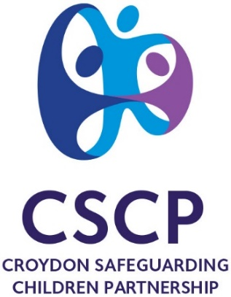

Escalation and Resolution Policy
Responding to professional disagreement in safeguarding children’s cases

Policy agreed | CSCP Quality Improvement Group
Date | May 2024
Review | Spring 2026

Contents
1 Introduction 3
2 Purpose and Scope 3
3 Definition 4
4 Principles and Stages of Escalation 5
5 Resolving disagreements in safeguarding: The stages of escalation 6
6 Recording and reporting 7
7 Policy Review 7
6.1 Professional Conflict Resolution 9
6.2 Escalation Notification Form 10

Introduction

Working Together to Safeguard Children 2023 sets out the expectations and requirements of what all organisations and practitioners should do to keep children safe, emphasising the need to focus on the needs of the child and work in partnership. Supporting and safeguarding children with identified needs is most effective when professionals work together to fulfil their specific and shared responsibilities for planning, interventions and decision making.

Within this it is recognised that working across organisational boundaries, and the crossing of different communities of practice will bring opportunities to safeguard children well; and also challenges. Amongst the most significant areas of challenge are understanding others’ professional discourses and contexts (this may include language, vocabulary, processes etc.) and raising concerns if another agency’s decision is considered to be poor or unsafe.

The importance of a culture which supports professional challenge cannot be underestimated. National and local serious case reviews have highlighted the importance of professionals challenging decisions to ensure the best outcomes for children and their families. Croydon SCRs have found that concerns about decisions made are often not followed up with robust professional challenge. Professional challenge is recognised as a positive activity and is a sign of good professional practice, a healthy organisation and an effective safeguarding system. Where there are differences and disagreements between agencies, a clear framework should be in place to ensure that timely and effective resolutions are made.

Purpose and Scope

The purpose of this policy is to explain what to do when any professional has a concern or disagreement with another agency’s decision or action related to a child. Its aim is to ensure that the focus is kept on the child’s safety and well-being through promoting a culture of professional challenge and providing framework for timely and effective resolutions.

Working Together 2023 states that ‘clear escalation policies for staff to follow when their child safeguarding concerns are not being addressed within their organisation or by other agencies’ should be in place. Similarly, Keeping Children Safe in Education promotes that - ‘if, after a referral, the child’s situation does not appear to be improving, the referrer should consider following the local escalation procedures. This policy therefore relates to the multi-agency children’s workforce working with children and families receiving support and services at Early Help, Child in Need, Child Protection and Looked After Children. This policy should be read in conjunction with the London Child Protection Procedures, Part B1 Chapter 11 ‘Professional Conflict Resolution’.

This policy does not replace the need for single agency dispute resolution procedures which should be in place to manage disputes on decisions between internal services (such as Children’s Social Care CERPs). Nor is this policy a complaint policy – if there is a complaint about professional conduct or a particular single agency policy should be followed. If the complaint is about the decisions of the Croydon Safeguarding Children Partnership, it should be directed to the CSCP Executive Group who should alert the CSCP Independent Scrutineer.

This Escalation and Resolution Policy, promotes both an informal (Stages 1- 2) and formal (Stages 3 -5) approach to resolving issues which arise

Definition

Problem resolution is an integral part of joint working to safeguard children, and professional challenge is a fundamental part of professional responsibility. In this context, escalation and resolution is about raising concerns or challenging decisions about practice or actions which, according to those holding the concerns, may significantly impact the protection and well-being of the child(ren).
Occasionally situations may arise when professionals within an agency consider that the decision made by professionals from another agency is not an adequate or a safe decision. Many professional challenges will be resolved on an informal basis by contact between the professionals and agencies involved.

However, drift arising out of professionals’ differences should be avoided; unresolved concerns should be addressed using this policy.

Disagreements and difficulties could arise in a number of areas, but are most likely to arise around:

- Deciding levels of safeguarding and protection needs
- Roles and responsibilities of agencies
- Quality and progression of plans at Early Help, Child in Need, Child Protection or for Looked After Children
- Professional vocabulary and communication issues
- Understanding professional perspectives.
In some instances, finding a way forward may not include changes to original decisions. However, through raising concerns and improving shared understanding through effective dialogue, the overall quality and robustness of the decisions will be greater.

Principles and Stages of Escalation

The policy applies the following principles to help ensure that best practice is upheld, these should be applied to both informal (Stages 1-2) and formal (Stages 3-5) approaches to resolving disputes:

The child’s safety is the focus - Disputes should never leave a child at risk; disputes should be raised in a timely manner and at the earliest opportunity. Maintaining an outcome focus on making the child safer, rather than focussing on processes - promotes openness between and amongst the professional networks.

Restorative in approach - Maintaining a principle of restorative approach helps create behaviours which are respectful of relationships, helping achieve effective and positive dialogue. An understanding of shared responsibility can be strengthened through ensuring everyone’s voice is heard and different positions understood; when all professional views and expertise are shared best outcomes for a child can be generated.

Professional curiosity and challenge are valued– By maintaining an open stance to receive and provide information – the act of asking questions of other professionals and responding to questions can help avoid assumptions, reduce defensiveness and encourage a move away from ‘knowing positions. At all stages it should be considered that whilst decisions may not change, any challenge to those decisions will be of benefit to the quality and robustness of those decisions.
Critically reflective – Where differences and disputes arise, or difficulties in complex and ‘stuck’ cases - it is important that critical reflective practice is upheld. Different professions and disciplines will hold particular theories of knowledge, practice, and opinion on what action is required. This policy supports convening a shared reflective and purposeful discussion to inquire and map professionals’ views, approaches, and interventions on the case. The CSCP supports use of a multi-agency reflective group consultation, to help unpick the presenting challenges and difficulties with the intention of achieving improved coherence of the issues and agreement of a way forward (refer to Professional Conflict Resolution).
Relationships and dialogue are valued – Across and between the child and family’s network it is important that professional relationships are established and maintained through effective dialogue, especially at points of transition and hand-over. Where differences, disputes or difficulties arise - direct and active dialogue should be prioritised to enable shared perspectives, exchange of information, and ensure the inclusion of the professional network in making decisions.

Resolving disagreements in safeguarding: The stages of escalation

It should always be clear that no child is at immediate risk of harm while disputes are being resolved, with resolutions focused on the child’s needs. The agency with concerns should discuss them with their line manager or safeguarding lead. If concerns persist, proceed to Stage 1.
Important reminders:
- Each stage should be completed within 7 working days or less, with all effort made to resolve at the earliest opportunity
- Concerns should be specific, evidence-based and accurately recorded on the child’s record. Discussions and outcomes of disagreements should be recorded.
- A multi-agency group reflective consultation should be actively considered at Stage 3, this is for cases which are stuck, or matters are proving difficult to resolve
- The CSCP has responsibility to identify practice and procedural issues, the Escalation Notification Form should be used and submitted at Stages 3, 5 and 5 as appropriate
- The principles of this policy underpin its application and should be considered when raising concerns
- These processes may not fit neatly into all agencies management structures; the principles and processes should be applied as best as possible.
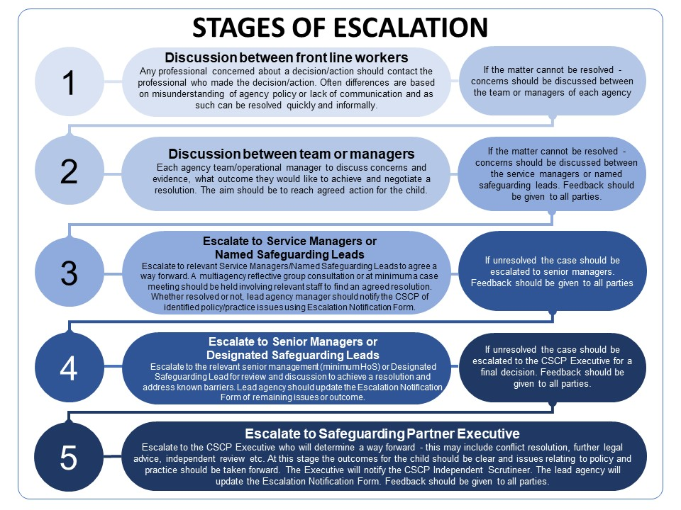

Recording and reporting

At all stages, a record should be kept on the child’s record within each agency’s case management systems. In particular this must include written communication about agreed outcomes and how outstanding issues will be pursued.
The CSCP will report on specific issues or recurring themes relating to practice and policy issues. This data will be collated from submitted Escalation Notification Forms (appendix B) and will be referred to the Quality Improvement Group for its recommendations on which aspects of practice or policy should be addressed. This data will also be used within the Annual Report.

Whistleblowing
Whistleblowing provides an avenue for professionals to raise concerns about unsafe practices, poor decision-making, or organisational misconduct that could impact a child’s safety or well-being. This policy encourages professionals to use established whistleblowing procedures when other escalation methods do not address the concern effectively.
Professionals who feel unable to raise their concerns through the standard escalation routes outlined in this policy or who believe their concerns have not been addressed appropriately should refer to their organisation's whistleblowing policy. Concerns can also be raised with the CSCP Independent Scrutineer or other appropriate safeguarding leads.
Clear records of whistleblowing disclosures, including their outcomes, should be maintained securely and separately from the child’s case files, ensuring confidentiality and protecting the whistleblower’s identity wherever possible.

6.2 Professional Conflict Resolution
A multi-agency reflective group consultation can be requested when there is disagreement and/or a case is stuck due to challenges and complexities. Engaging in such a consultation creates space for dialogue which can help improve understanding between professional practices, give clarity to contexts and understanding what’s important to different practices; and explore ways forward.
Process
- A service manager involved with the case should request a multi-agency reflective group consultation via the CSCP Manager by emailing CSCP@croydon.gov.uk
- A multi-agency reflective group consultation will be facilitated by Children’s Social Care Systemic Lead
- The structure of the session will be drafted by the facilitator of the session and agreed by the group. These might include:

- Agreed principles for the session.
- What is required of professional’s preparation beforehand.
- Agencies’ present summary of dilemmas and concerns with clarifying questions.
- Facilitated discussion exploring impact, perspectives, positions, possibilities etc.
- Making sense of situation, identifying patterns and possibilities.
- Building hypotheses.
- Agreeing actions linked to hypotheses.
- Agreeing evaluation and review.

Policy Review

This policy will be reviewed biennially by the CSCP Quality Improvement Group.

Appendix - Escalation Notification Form

The purpose of this template is to capture detail of significant or recurring practice or policy issues. In capturing this detail, the CSCP Quality Improvement Group will agree a response to make improvements – this may relate to a process, policy or practice issue. Use of this policy will be reported on annually.
When to complete this form:
- This form should be used at Stage 3, and subsequently updated if moving to
- Stages 4 and 5
- Completed forms should be saved locally and relevant information should be added to the child’s record
- Completed forms should be emailed securely to CSCP@croydon.gov.uk
- If printing this form, expand all fields before printing.

Details of person completing notification
Name
Role
Agency
Email
Date
Details of child/young person
Full name
Date of birth | Click or tap to enter a date.
Gender | Choose an item.
Ethnicity | Choose an item.
SEND | Choose an item.
Stage 3 | This should be completed in all cases where Stage 3 has been reached, it should be submitted whether issue is resolved or not. If unresolved Stage 4 should be followed.
Brief description of your concerns (incl. key dates, evidence of need, key procedural issue/disagreement, summary of interventions to date)
Is the matter resolved?  (please select from the drop down menu) | Yes | If yes, please provide details of the outcome below.  If no, please move to section 4
Decision / Outcome
Summary of key learning
Date

Stage 4 | This should be completed in all cases where Stage 4 has been reached, it should be submitted whether issue is resolved or not. If unresolved Stage 5 should be followed.
Brief description of your concerns (incl. key dates, evidence of need, key procedural issue/disagreement, summary of interventions to date)
Is the matter resolved?  (please select from the drop down menu) | No | If yes, please provide details of the outcome below.  If no, please move to section 5
Decision / Outcome
Summary of key learning
Date

Stage 5 | This should only be completed in all cases where all the previous stages remain unresolved.
Outline concerns along with supporting evidence.
Conclude with a request for the Executive Group to consider.
Partnership Executive
Decision / Outcome
Summary of key learning
Date

Submit the completed form via secure email to the CSCP Manager at CSCP@Croydon.gov.uk

Working Together to Safeguard Children 2023
CSCP Quality Improvement Group is a multi-agency partnership group

